# Assignment – 3

**Assigned To = Raghav Pathak, Rajesh Dhangar, Ayush Kumar, Anshul Pathak**

**Chapter = Understanding Quadrilateral**

**Submission Date = 30 July 2022 MM = 20**

Q1. The exterior angle of a regular polygon is one-fifth of its interior angle. How many sides have the polygon?

Q2. Find the measure of an interior angle of a regular polygon having 15 sides.

Q3. The interior angle of a regular is 108°. Find the number of sides of the polygon.

Q4. he perimeter of a parallelogram is 150 cm. One of its side is greater than the other by 25 cm. Find length of all sides of the parallelogram.

Q5. Adjacent sides of a rectangle are in the ratio 5 : 12, if the perimeter of the rectangle is 34 cm, find the length of the diagonal.

Q6. The opposite angles of a parallelogram are (3x + 5)° and (61 – x)°. Find the measure of four angles.

Q7. Find the measure of all four angles of a parallelogram whose consecutive angles are in the ratio 1 : 3.

Q8. In the given figure, ABCD is a parallelogram. Find x, y and z.

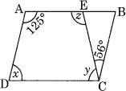

Q9. Find x in the following figure

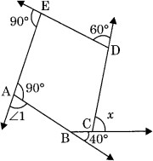

Q10. ABCD is a parallelogram with ∠A = 80°. The internal bisectors of ∠B and ∠C meet each other at O. Find the measure of the three angles of ΔBCO.

